

C PROGRAMMING ASSIGNMENT
Student Submission Template
Student Name | ROHITHKUMAR R
Register Number | 1911260135
Course Code & Name | CSA0211
Slot | D
Assignment / Task Title | CO-1 AT-2
GitHub Repository URL | https://github.com/Rohith45-ultra/CSA0211-1911260135-Cprogramming.git
Submission Date | 28/10/2026

TASK 5 — Organise with Header Files and Conditional Compilation
Task / Problem Statement
Move tariff definitions and the function prototype into a guarded header and add optional debug output.. Aim
To demonstrate modular C source files, include guards, and conditional compilation. Concept / Theory
A header guard prevents duplicate inclusion within a translation unit. Quoted includes normally search the local directory first; angle-brack
Procedure / Algorithm
- Keep declarations/constants in Task05_tariff.h.
- Implement compute_bill in Task05_tariff.c.
- Call it from Task05_main.c.
- Compile all source files together.
- Compile again with -DDEBUG and compare output. Program / Source Code

File: Task05_tariff.h
#ifndef TASK05_TARIFF_H #define TASK05_TARIFF_H #define SLAB1_UNITS 100
#define SLAB2_UNITS 200 #define RATE1_PAISE 0L #define RATE2_PAISE 225L #define RATE3_PAISE 450L
#define FIXED_CHARGE_PAISE 5000L
long compute_bill(int units); #endif
File: Task05_tariff.c #include <stdio.h> #include "Task05_tariff.h"
long compute_bill(int units)
{
long paise = FIXED_CHARGE_PAISE; int slab2 = 0;
int slab3 = 0;
if (units < 0) return -1L;
if (units > SLAB1_UNITS)
slab2 = units < SLAB2_UNITS ? units - SLAB1_UNITS : SLAB2_UNITS - SLAB1_UNITS;
if (units > SLAB2_UNITS) slab3 = units - SLAB2_UNITS;
paise += (long)slab2 * RATE2_PAISE; paise += (long)slab3 * RATE3_PAISE; if (units <= SLAB1_UNITS)
paise += (long)units * RATE1_PAISE; else
paise += (long)SLAB1_UNITS * RATE1_PAISE; #ifdef DEBUG

fprintf(stderr, "[DEBUG] units=%d slab2=%d slab3=%d bill_paise=%ld\n", units, slab2, slab3, paise);
#endif return paise;
}
File: Task05_main.c #include <stdio.h> #include "Task05_tariff.h" int main(void)
{
int units;
printf("Enter units consumed: ");
if (scanf("%d", &units) != 1 || units < 0) { fprintf(stderr, "Invalid units.\n");
return 1;
}
long paise = compute_bill(units);
printf("Bill = Rs %ld.%02ld\n", paise / 100, paise % 100); return 0;
}

Output Screenshot
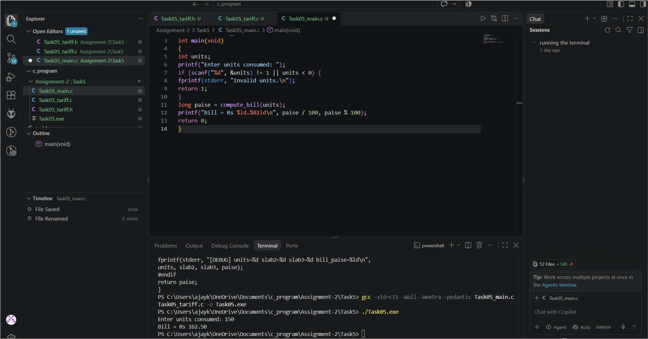

Analysis / Discussion
Compile with `gcc -std=c11 -Wall -Wextra -pedantic Task05_main.c Task05_tariff.c -o Task05` and with `-DDEBUG` added to
compare diagnostic output. A run-time debug flag requires a test at run time; conditional compilation can omit the debug
statements entirely from a non-debug build. Result
The billing program was organized into separate source and header files to improve code readability, reusability, and maintainability.

TASK 6 — Read and Print Data Correctly
Task / Problem Statement
Read household information using scanf, validate input, and print money as rupees and paise. Aim
To use correct format specifiers and reject invalid input Concept / Theory
. Use the format specifier matching the pointer/type: %d for int, %u for unsigned int, %ld for long,
%lld for long long, %f for float input, %l Procedure / Algorithm
- 1. Prompt for household ID, units, and bill amount in paise.
- Check that scanf reads all three values.
- Reject a negative bill.
- Print money using quotient and remainder by 100.
- Try valid input and invalid text input.

Program / Source Code
File: Task06_io.c #include <stdio.h> int main(void)
{
int household_id; unsigned int units; long long bill_paise;
printf("Enter household ID, units and bill amount in paise: ");
if (scanf("%d %u %lld", &household_id, &units, &bill_paise) != 3) { fprintf(stderr, "Invalid input. Enter an integer ID, units, and paise.\n"); return 1;
}
if (bill_paise < 0) {
fprintf(stderr, "Bill cannot be negative.\n"); return 1;
}
printf("Household: %d\n", household_id); printf("Units: %u\n", units);
printf("Bill: Rs %lld.%02lld\n", bill_paise / 100, bill_paise % 100);

return 0;
}
Output Screenshot
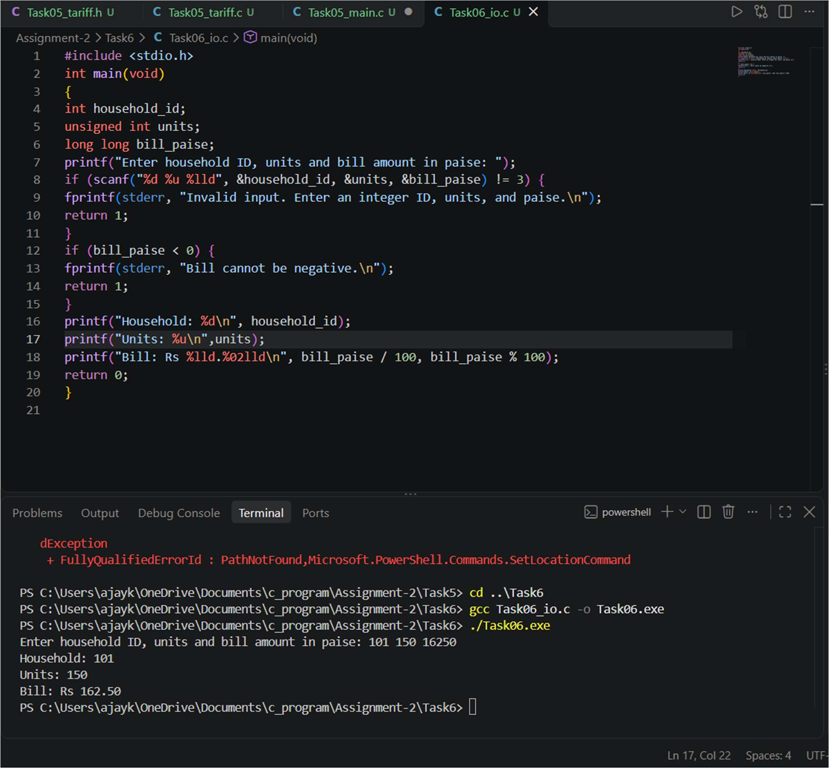
Analysis / Discussion
Using fgets followed by strtol/sscanf gives more control over a whole input line and can make recovery from invalid input easier.
Processing a line is O(L) for line length L and requires a buffer of O(L) or a fixed maximum buffer. Result
.The program was designed to accept the required input from the user and display the corresponding billing information.

TASK 7 — Control Type Conversion and Precision
Task / Problem Statement
Demonstrate integer division, casts, floating-point representation, and exact currency storage. Aim
To identify unexpected results caused by implicit and explicit type conversions. Concept / Theory
Integer division truncates the fractional part. Casting after integer division cannot restore it. Binary floating point cannot represent every decimal fraction exactly. Integer paise avoids floating-point rounding for whole-paise tariffs.
Procedure / Algorithm
- Run the precision program.
- Compare 5/2, (double)(5/2), and 5.0/2.
- Observe the printed 0.1 + 0.2 value.
- Print an amount using integer paise.
- Explain three unexpected result Program / Source Code
File: Task07_precision.c #include <stdio.h>
int main(void)
{
printf("5 / 2 = %d\n", 5 / 2);
printf("(double)(5 / 2) = %.1f\n", (double)(5 / 2)); printf("5.0 / 2 = %.1f\n", 5.0 / 2);
printf("0.1 + 0.2 = %.17f\n", 0.1 + 0.2);
long long paise = 16250;
printf("Integer paise: Rs %lld.%02lld\n", paise / 100, paise % 100); return 0;
}
Output Screenshot

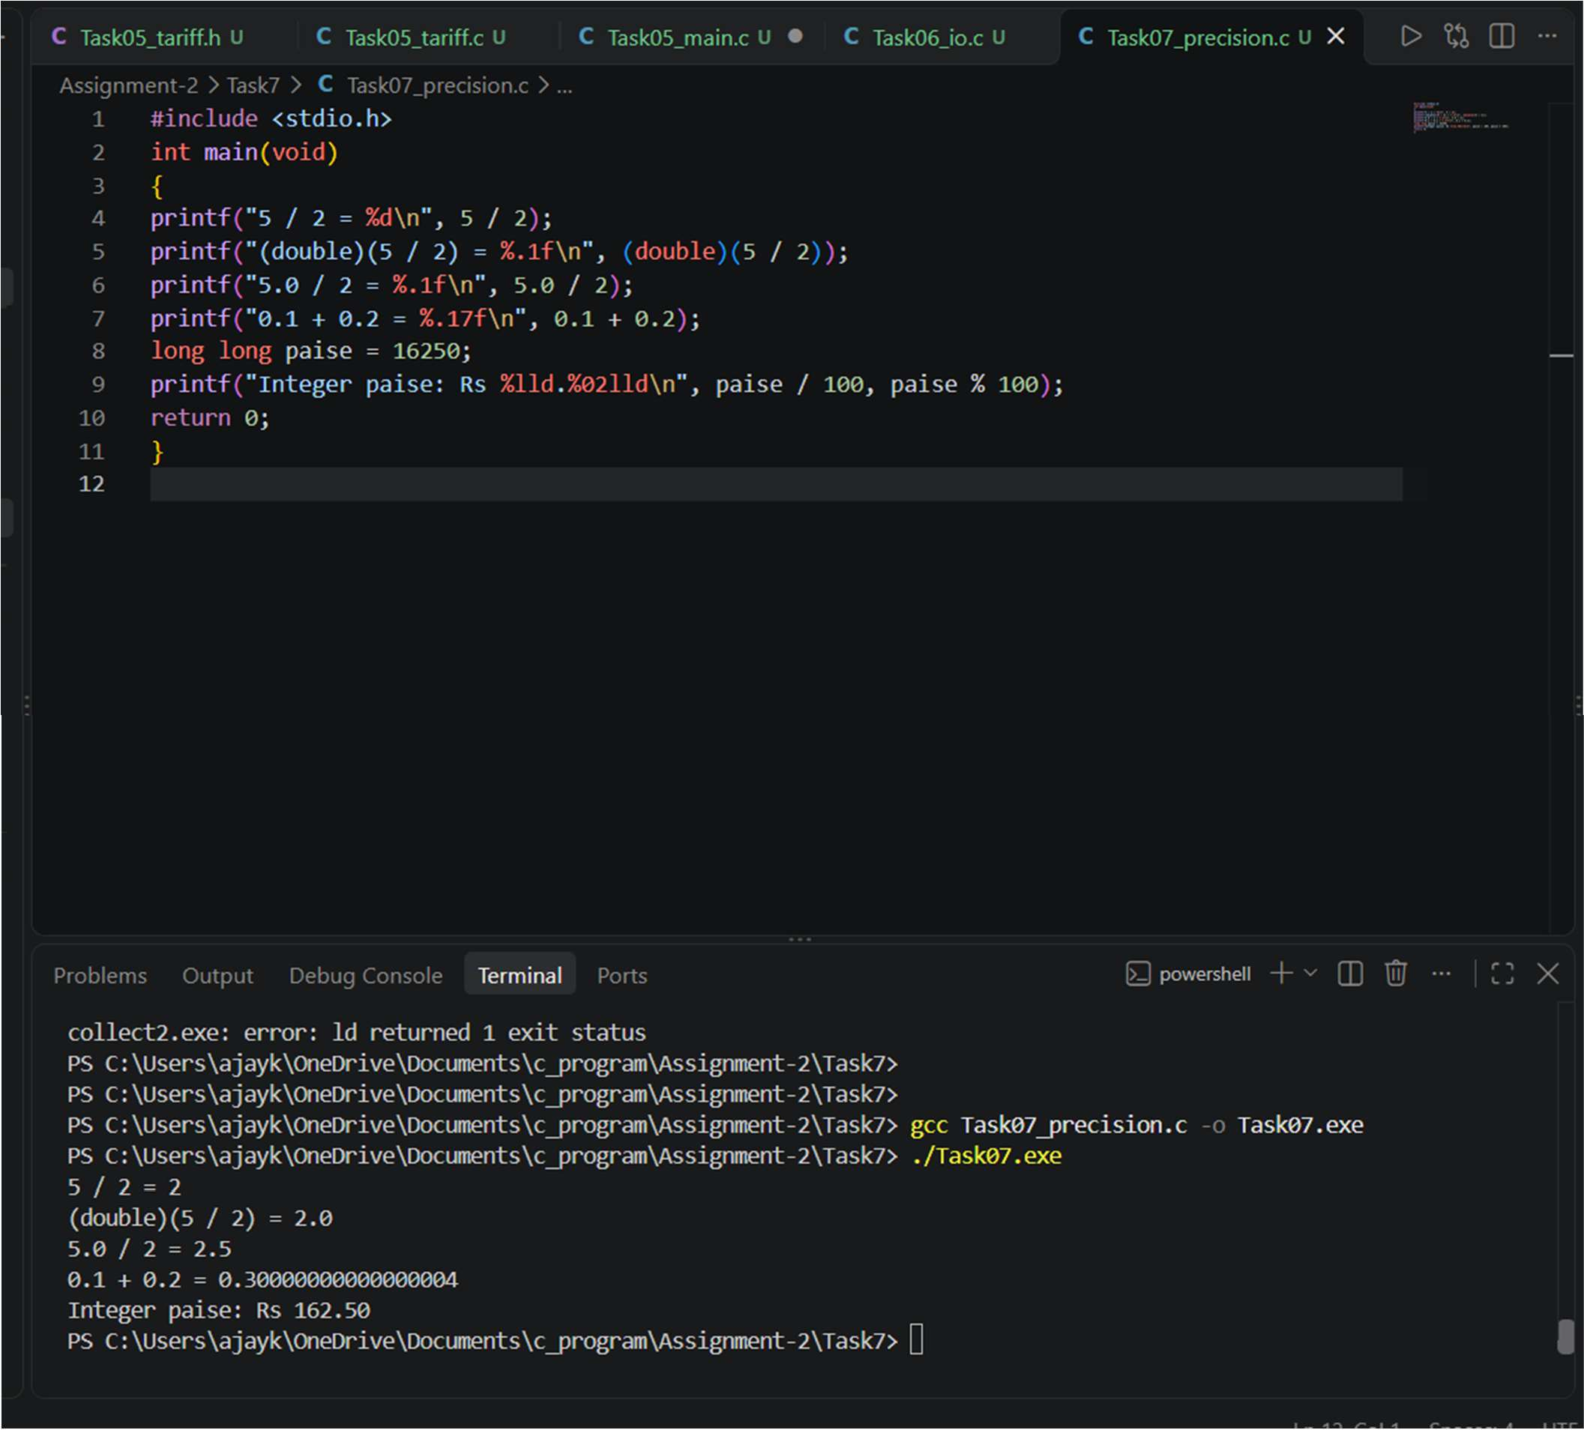

Analysis / Discussion
Both integer and floating-point additions are O(1) per operation. Integer paise uses a fixed-width integer and avoids
fractional-paise rounding. For a floating-point alternative, rounding should be applied consistently, usually at a defined billing boundary; error can accumulate across many bills.
Result
The program's numeric calculations and data representation were examined to improve the accuracy of billing calculations.

TASK 8 — Trace the Compilation Process
Task / Problem Statement
Demonstrate preprocessing, assembly generation, object compilation, linking, and error categories Aim
To understand how GCC transforms C source into an executable and how warnings help find problems Concept / Theory
The preprocessor expands macros/includes, -S emits assembly, -c emits an object file, and linking combines object files and libraries into an executable. Compile-time, link-time, and run-time errors occur at different stages.
Procedure / Algorithm
- Run gcc -E Task09_billing.c -o preprocessed.i.
- Run gcc -S Task09_billing.c -o assembly.s.
- Run gcc -c Task09_billing.c -o billing.o.
- Link with gcc billing.o -o billing.
- Compile with -Wall -Wextra -pedantic and record warnings/errors. Program / Source Code
File: Task08_compile_steps.txt
From the folder containing Task09_billing.c, run:
gcc -E Task09_billing.c -o preprocessed.i gcc -S Task09_billing.c -o assembly.s gcc -c Task09_billing.c -o billing.o
gcc billing.o -o billing
gcc -std=c11 -Wall -Wextra -pedantic Task09_billing.c -o billing
Inspect preprocessed.i to see expanded macros and included header content. assembly.s contains assembly language.
billing.o is an object file; it is not yet a standalone executable. The final link command creates the executable.
Compile-time error example: omit a semicolon.
Link-time error example: call a function that is declared but has no definition.
Run-time/logic error example: accept an invalid meter reading and calculate an incorrect bill. Write down the actual warnings/errors you observe and how you fixed them.
File: Task09_billing.c #include <stdio.h> #include <stdint.h> #include <inttypes.h>
#define SLAB1_UNITS 100U #define SLAB2_UNITS 200U #define RATE1_PAISE 0LL #define RATE2_PAISE 225LL #define RATE3_PAISE 450LL
#define FIXED_CHARGE_PAISE 5000LL #define ROLLOVER_PREVIOUS_MIN 60000U #define ROLLOVER_CURRENT_MAX 1000U
typedef uint16_t meter_t;
static uint32_t consumption(meter_t previous, meter_t current)
{
/* Unsigned 16-bit arithmetic gives 256 for 65400 -> 120. */ return (uint16_t)(current - previous);
}

static int valid_readings(unsigned int previous, unsigned int current)
{
if (previous > UINT16_MAX || current > UINT16_MAX) return 0; if (current >= previous) return 1;
return previous >= ROLLOVER_PREVIOUS_MIN && current <= ROLLOVER_CURRENT_MAX;
}
static long long compute_bill(uint32_t units)
{
uint32_t slab2 = 0; uint32_t slab3 = 0;
long long paise = FIXED_CHARGE_PAISE; if (units > SLAB1_UNITS)
CSA02 C Programming Assignment — Tasks 5–8 Page 7
slab2 = units < SLAB2_UNITS ? units - SLAB1_UNITS : SLAB2_UNITS - SLAB1_UNITS;
if (units > SLAB2_UNITS) slab3 = units - SLAB2_UNITS;
paise += (long long)slab2 * RATE2_PAISE; paise += (long long)slab3 * RATE3_PAISE; return paise;
}
static void print_money(long long paise)
{
printf("Rs %lld.%02lld", paise / 100, paise % 100);
}
int main(void)
{
unsigned int household_id, previous_input, current_input; meter_t previous, current;
uint32_t units; long long bill;
printf("Household ID: ");
if (scanf("%u", &household_id) != 1) { fprintf(stderr, "Invalid household ID.\n"); return 1;
}
printf("Previous meter reading (0-65535): "); if (scanf("%u", &previous_input) != 1) { fprintf(stderr, "Invalid previous reading.\n"); return 1;
}
printf("Current meter reading (0-65535): "); if (scanf("%u", &current_input) != 1) { fprintf(stderr, "Invalid current reading.\n"); return 1;
}
if (!valid_readings(previous_input, current_input)) { fprintf(stderr, "Invalid readings or unsupported rollover.\n"); return 1;
}
previous = (meter_t)previous_input; current = (meter_t)current_input;
units = consumption(previous, current); bill = compute_bill(units);
printf("\nHousehold ID: %u\n", household_id);

printf("Units consumed: %" PRIu32 "\n", units); printf("Fixed charge: Rs 50.00\n");
printf("Total bill: "); print_money(bill); printf("\n");
return 0;
}
Output Smaple:
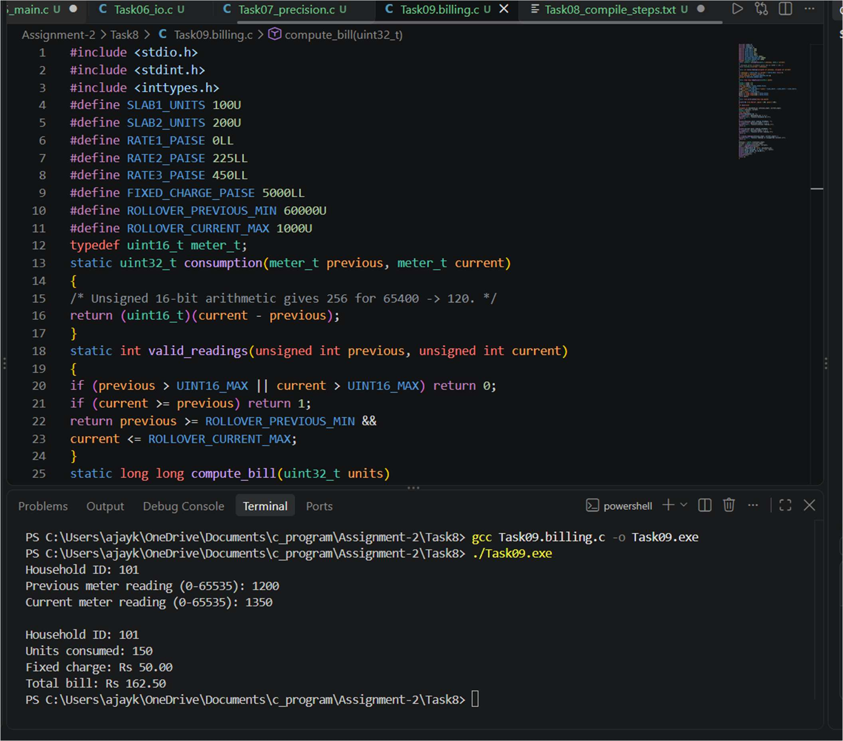

Analysis / Discussion
The provided example reads energy in Wh, interval start hour, and base tariff in paise/kWh. It demonstrates a run-time tariff and 20% peak surcharge. It assumes an interval lies entirely within

peak or off-peak time; a production implementation must split intervals crossing 18:00 or 22:00 and validate arithmetic bounds..
Result
The compilation procedure was documented to help identify syntax errors and prepare the program for execution.

